## The Karate Canada Academic Achievement Award recognizes the hard work and dedication of an individual who demonstrates the ability to reach the level of national team member while excelling in their scholastic commitments.

Nominee must be a member in good standing of a recognized Karate Canada partner organization (PTSO).

2019 Academic Achievement Award

Nomination Form

**NOMINEE INFORMATION**

Name:

Address:

City:

Province:

Postal Code:

Email:

Phone:

**NOMINATED BY**

Nomination can be made by the Head Coach and/or President of a recognized PTSO. Nomination is to include a brief resume of the pertinent experience of the nominee, and any letters of support.

Nominator:

Address:

City:

Province:

Postal Code:

Email:

Phone:

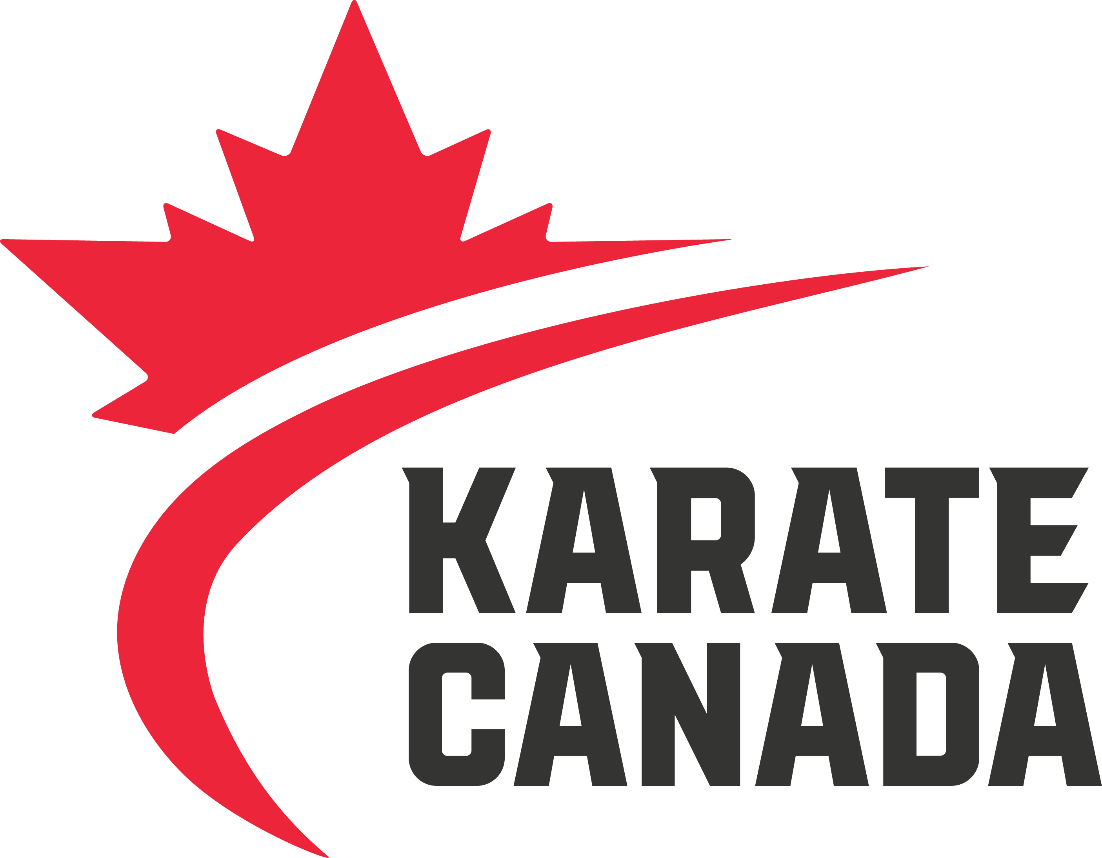

Education Level: Secondary _____ Post-Secondary ______

**Please email completed nomination form and supporting documents to** [cheryl.tataryn@karatecanada.org](mailto:cheryl.tataryn@karatecanada.org) **by Monday, April 22, 2019.**

* Be a current member of the Karate Canada National Team Roster
* Have supporting nomination material evaluated in the following order:

1. Athlete with the highest status on the Junior/Senior National team; and
2. Athlete with the highest grades.

* Nominator must provide a copy of current school transcript, scholastic bio and karate bio as part of nomination process.

Support the nomination by providing examples of the nominee in the following areas:

C/O CANADIAN OLYMPIC COMMITTEE

500 BOUL. RENÉ LÉVESQUE OUEST, MONTRÉAL H2Z 1W7

**T** 514 252:3209 **F** 514 252:3211 **KARATECANADA.ORG**

Additional pages may be submitted, if required.