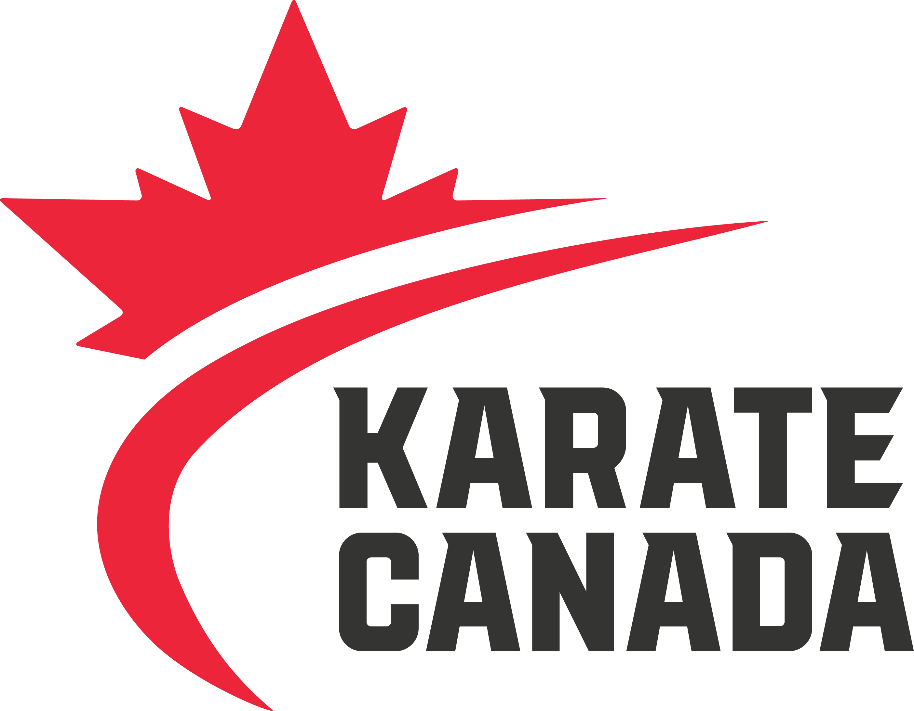

NCCP #:

## The Karate Canada Coach Developer of the Year Award recognizes an outstanding contributor to the promotion, growth and development of Karate Canada’s NCCP programs. It will recognize a Learning Facilitator, Evaluator or Master Coach Developer for their exceptional ability to mentor and develop certified coaches and instructors.

Nominee must be a member in good standing of a recognized Karate Canada partner organization (PTSO).

2019 Coach Developer of the Year

Nomination Form

**NOMINEE INFORMATION**

Name:

Address:

City:

Province:

Postal Code:

Email:

Phone:

**NOMINATED BY**

Nomination can be made by a recognized PTSO and/or a member of the current Karate Canada NCCP Committee. Nomination is to include a brief resume of the pertinent experience of the nominee, and any letters of support.

Nominator:

Address:

City:

Province:

Postal Code:

Email:

Phone:

* Be a member in good standing of a recognized Karate Canada partner organization (PTSO);
* Develop, support and challenge coaches to go on honing and improving their knowledge and skills;
* Provide positive and effective sport experiences for all participants;
* Involve in delivery of workshops and/or evaluation of coaches;
* Possess great communication, leadership and observation skills;
* Attend professional development opportunities for growth and continuously seek to improve personal abilities;
* Be professional, approachable, ethical and organized.

Support the nomination by providing examples of the nominee in the following areas:

C/O CANADIAN OLYMPIC COMMITTEE

500 BOUL. RENÉ LÉVESQUE OUEST, MONTRÉAL H2Z 1W7

**T** 514 252:3209 **F** 514 252:3211 **KARATECANADA.ORG**

Additional pages may be submitted, if required.

**Please email completed nomination forms and supporting documents to** [alexandra.roy@karatecanada.org](mailto:alexandra.roy@karatecanada.org) **by April 22, 2019.**