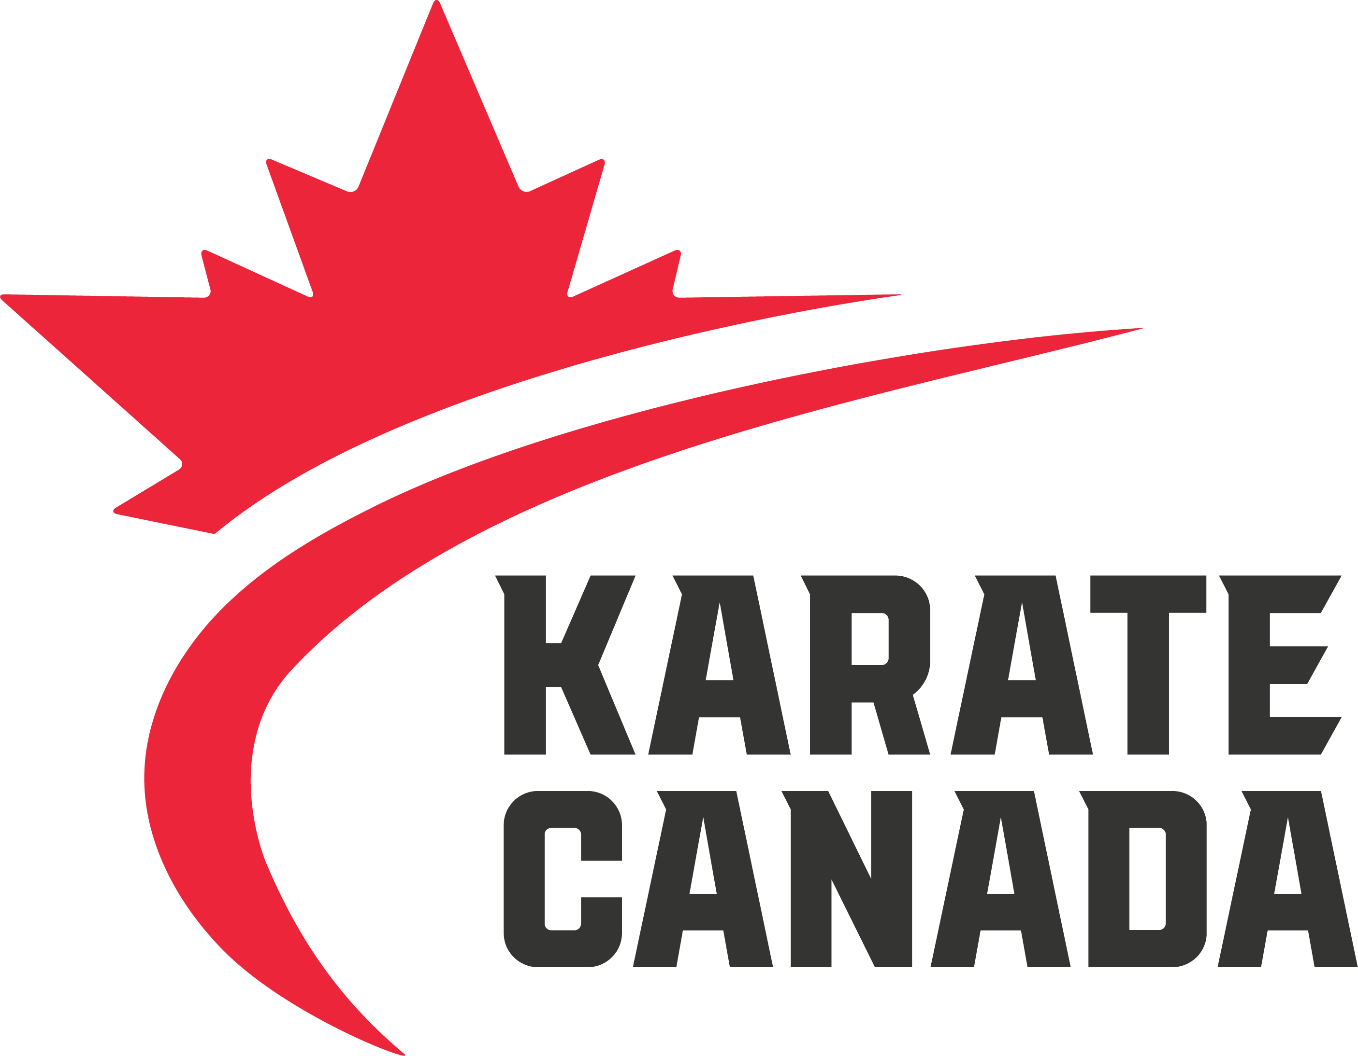

Nominee must be a member in good standing of a recognized Karate Canada partner organization (PTSO).

2019 Official of the Year

Nomination Form

## The Karate Canada Official of the Year Award recognizes the outstanding body of professional officials within the sport of Karate in Canada.

**NOMINEE INFORMATION**

Name:

Address:

City:

Province:

Postal Code:

Email:

Phone:

**NOMINATED BY**

Nomination can be made by the Head Coach and/or President of a recognized PTSO. Nomination is to include a brief resume of the pertinent experience of the nominee, and any letters of support.

Nominator:

Address:

City:

Province:

Postal Code:

Email:

Phone:

,

**Please email completed nomination forms and supporting documents**

**by Monday, April 22, 2019 to** [**Cheryl.tataryn@karatecanada.org**](mailto:Cheryl.tataryn@karatecanada.org)

* Demonstrate ability to work as an Official at the National and/or International level.
* Display an exceptional understanding of the rules of Karate as well as how to apply them
* Convey professionalism and be respectful at all times.
* Have a willingness to travel to tournaments or events in order to further their education and experience as an Official.
* Train(ed) to advance their Official’s skills through educational opportunities;
* Readily accept feedback from mentors or assessors.

Support the nomination by providing examples of the nominee in the following areas:

C/O CANADIAN OLYMPIC COMMITTEE

500 BOUL. RENÉ LÉVESQUE OUEST, MONTRÉAL H2Z 1W7

**T** 514 252:3209 **F** 514 252:3211 **KARATECANADA.ORG**

Additional pages may be submitted, if required.